Station Rose - Dave Remixed (Gigolo Records)
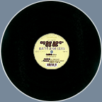  more images | Format: | 12"
 | Catalog#: | GIGOLO 46
 | Released: | 2000
 | Country: | Germany
 | Style: | Techno, Electro
 | Notes: | Written by Gary Danner in 1992.  Recorded & engineered by Atom Heart.
 | Rating: | 3.5/5 (11 votes) Rate It
 | submitted by: teori
Tracklisting:
a1 | Original (08:39)
b1 | Hal 9000 RMX (06:45)  remix by Hal 9000
b2 | Heinrich Muller Stanley Kubricks Vision Mix (07:26)  remix by Heinrich Mueller

